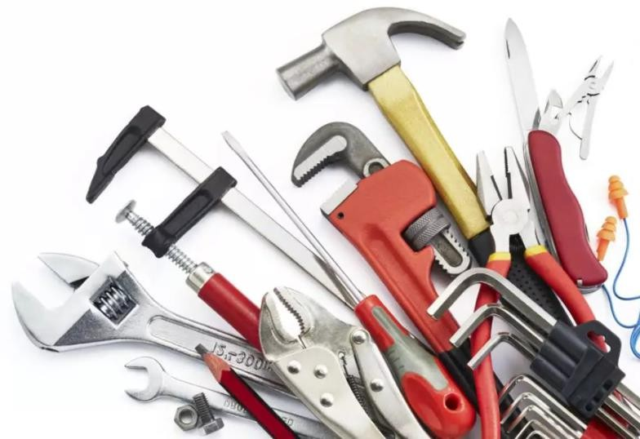

MATERIAL TRADING

We are the stockiest and suppliers of Industrial & Construction Material requirements in Kingdom of Saudi Arabia. Our network in the material trading have wide range of Hand & Power Tools, Hardware, Engineering goods, Mechanical, Electrical, Instrumental, Lifting, Hydraulic, Industrial chemicals, Lubricants & building materials of various brands.
We also supply various safety & security supplies like CCTV, GPS Systems, PWAS System, Burglar Alarm systems, Emergency EVAC, Office security systems, Security patrol monitoring System & programming etc.

Hand & Power Tools
The variety of essential hand and power tools necessary to perform most maintenance operations safely and efficiently like, Adjustable Spanner Wrenches, Roller Clutch & C-Clamps, Crimper, Bender & Formers, Manual Fastener Removal tools, Nut & Screwdrivers, Magnetizers & Demagnetizers, Hydraulic rescue kits, T-Torque Wrenches, Valve Wheel Wrenches, Heavy duty Wide roll & Hinged Pipe Cutters, Plier, puller & Separator, Scissor, Shears & Snips, Double Handle, Crank Handle & Mechanical Rachet, Point Shallow Sockets to Deep & Turbo Impact sockets.

Angle & Bench Grinders, Chisels, Chop-saw & Jigsaws, Circular Saws, Miter Saws, Asphalt Blades, Reciprocating Saws, Magnetic drills, Diamond Core Drills, Rotary & Percussion Drills, Non-Sparking Brass Sledge, Rotary & Demolition Hammers.

RIAL TRADING

MECHANICAL
- Pipes/Tubes
- Fittings & Fasteners
- Flanges
- Valves
- Welding Accessories

INSTRUMENT & CONTROL
- Solenoid Valves
- Instrumentation Valves
- Process control Valves
- Positioners & Actuators

ELECTRICAL
- Switches & Sockets
- Plugs & Boxes
- Wiring Devices
- Panel Boards
- Cable Lugs & Tools
- Transformers
- PVC Conduit Fittings

HVAC
- Duct Board
- Duct Wrap
- Mineral Wool
- Wired & Ceramic Blankets

- GRP & HDPE PFP
- Structural Steels
- Structural Gratings
- Metal Sheets

- Calibration Equipment’s
- Flow Gauges & Level Gauges
- Process controllers
- Indicators & Recorders

- Electrical wire
- Telephone Cable
- EMT Rigid & Conduits Fittings
- Industrial ventilating Fans
- UPS Systems
- Solar power systems

- PIR Insulation Board
- Woven Fire blankets
- Fire & Smoke Damper
- Hydro Testing Equipment’s

MATERIAL TRADING

SAFETY
- Personnel Protective Equipment's
- FRC – Fire Resistant Clothing's
- Breathing Equipment’s
- Emergency Response Equipment’s
- Fire protection Equipment’s
- Fire Extinguishers
- Safety Monitoring Systems
- Security & Safety Solutions

RIGGING LIFTING
- Wire rope accessories
- Snatch block & Sheave Blocks
- Crane pulley
- Hooks & Shackle
- Ratchet strap & Load binders
- Turnbuckles & Rigging Screws
- Master Rings & Fittings
- Load Suspension Eyes etc.

BUILDING MATERIALS
- Corrugated Sheets
- Gratings & Handrails
- Checkered
- Binding Wires
- Pipe Supports
- Wire Mesh
- Cordless Tools
- Steel Angles
- Deformed Steel Bars
- Steel Clamps
- Anchors & Fasteners

- Angle Grinders
- Chop-saw & Jigsaws
- Circular Saws
- Miter Saws
- Asphalt Blades
- Reciprocating Saws
- Magnetic drills
- Diamond Core Drills
- Rotary & Percussion Drills
- Rotary & Demolition Hammers

SOIL MATERIALS
- Normal Sand
- Clean Sand
- Gravel (All Sizes)
- Marl
- Base Course
- Sub Base
- Select Fill

WOOD MATERIALS
- Beach Wood
- Board Ply
- MDF Ply
- Plywood
- Joinery Timber
- Polystyrene
- Bitumen Board

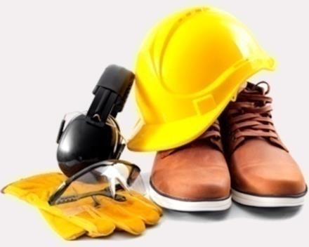
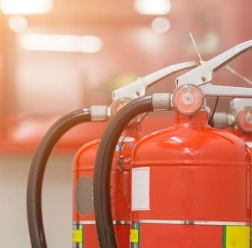
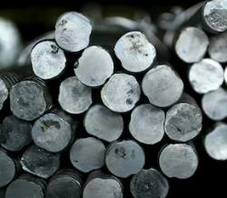
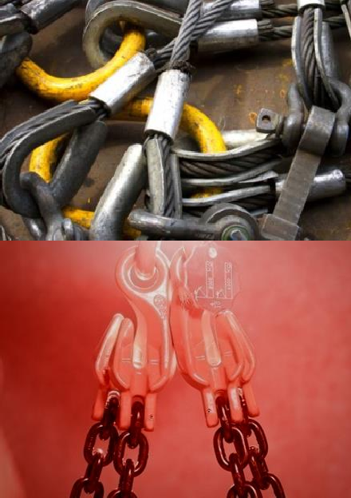
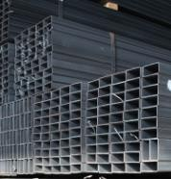
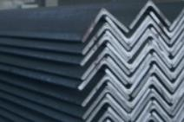


PIPES & FORGED BARS
Materials in: Stainless Steel, Special Steel, Super alloys, Nickel Alloys, Alloy Steels & MS Steels.
Form : Round, Square, Rectangular, Hydraulic
Range: All Sizes in Sch 5 - 40, Std, 60-80 XS,
100, 120, 140, 160 & XXS as Per NACE MR 01 75

Type: Seamless / ERW / Welded / Fabricated

Elbow B/W & SW Reducer-ECC/CON
TEE Equal & Unequal BW/SW Stub end -Short Neck & Long Neck SORF, WNRF, SWRF & All Type

Materials in Stainless Steel, Carbon steel, Alloy Steel, Duplex Steel and Nickel Alloy.
SIZE: ½ to 24 Inch (SCH: 10S – 160)

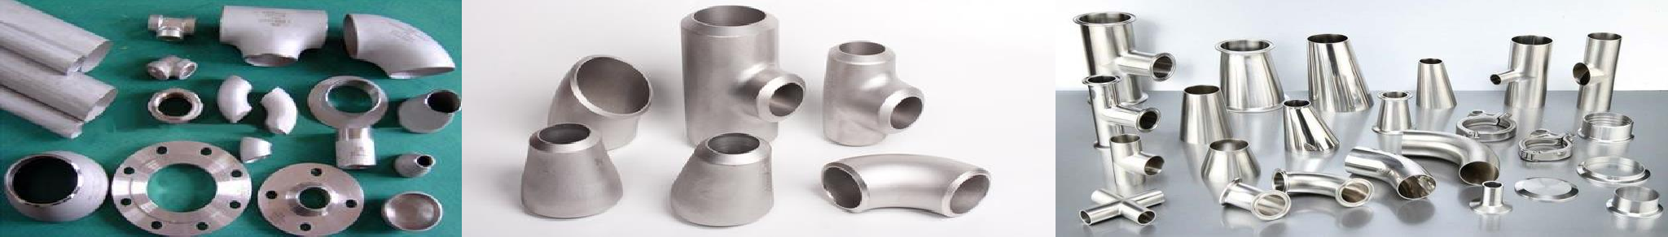

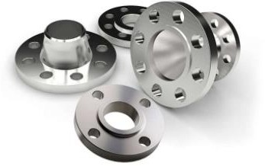
Flanges
Weld neck, Slip on, Lap Joint, Socket weld, Blind, Spectacle Blind, Paddle Blind, Reducing, Spacer, Expander, Adapter Split, Studding Outlets, Threaded & Orifice

Materials in: Stainless Steel, Special Steel, Super alloys, Nickel Alloys, Alloy Steels & MS Steels.

MATERIAL TRADING

Ball valves | Gate valves | Globe valves Check valves | Plug valves | Butterfly valves
Materials in: Carbon steel & stainless steel. from 150LB ~600LB 2” ~48”

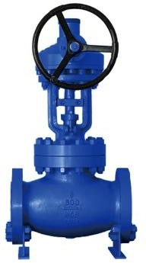
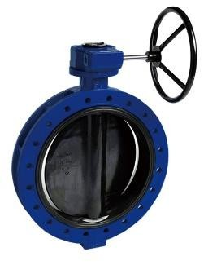
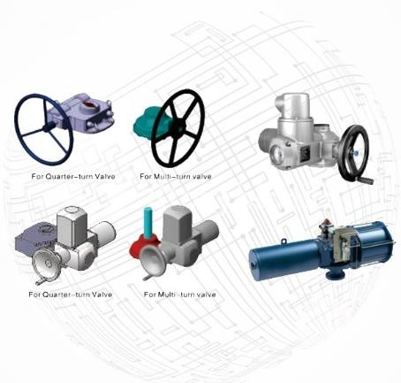
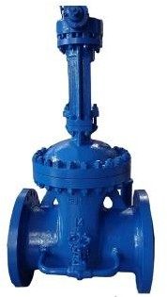
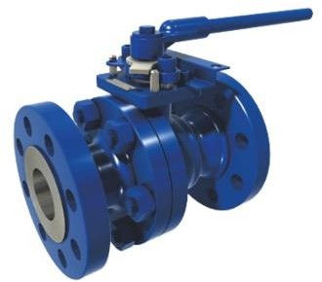
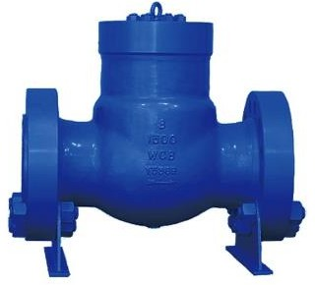
FASTNERS & FITTINGS

BOLTS AND SCREWS
  - Hex Bolts and Screws
  - Bent Bolts and Screws
  - Cap Bolts and Screws
  - 12-Point Bolts and Screws
  - Shoulder Bolts and Screw
  - Oval Neck Bolts and Screws

NUTS & WASHERS
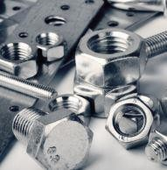
  - Cap Nuts
  - Hex & Square Nuts
  - 12-Point Nuts
  - Flat Washers
  - Lock Washers
  - Beveled Washers

Materials in: Stainless Steel, Alloy Steels, Aluminum Alloys, Carbon Steels, Super alloys, Copper Alloys, Titanium Stainless Steels & Tool Steels

OIL STORAGE DRUM & MATERIAL HANDING PALLETS – WOOD / SS
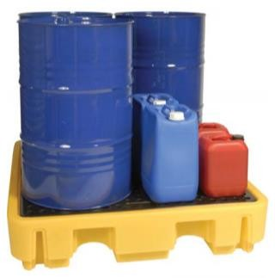
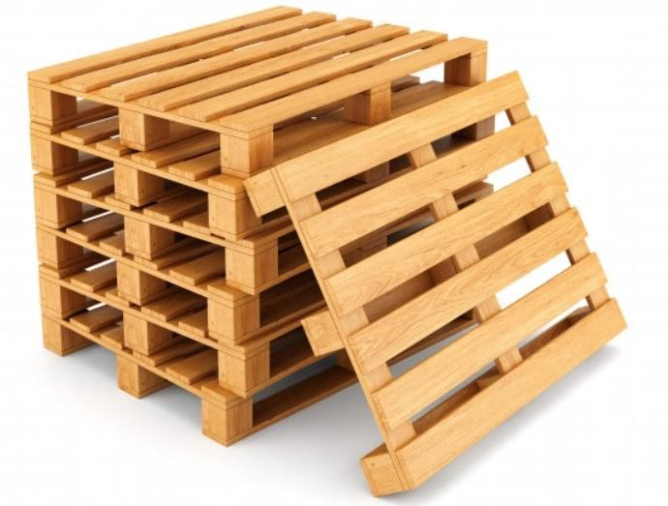
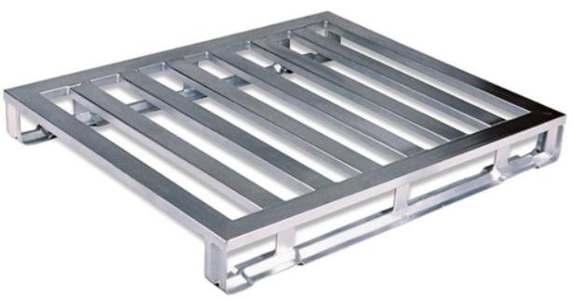

CUSTOMIZED MANUFACTURING

MATERIAL TRADING
Grinding Balls | Grinding Cylpebs Ball Mill Liner | SAG Mill Liner
AG Mill Liner | Rod Mill Liner.
Jaw Crusher Parts | Cone Crusher parts Impact Crusher Parts | Hammer Crusher Parts.

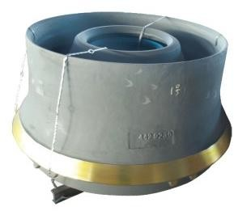

Cement, Copper & Gold Mine Grinding Use
High Chrome, Steel & Alloy ball Casting
Crusher Manganese and high Chrome Shredder

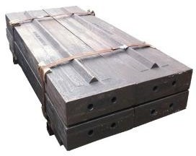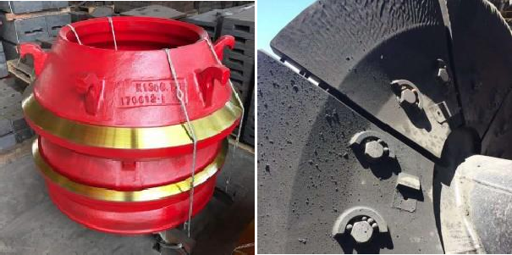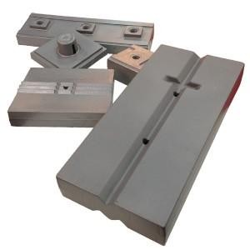

Wind-solar Intelligent Street Light
Monitoring Equipment (Traffic & Security Usage)
Medium-small Wind Turbine & Solar Panels
High efficiency / Performance Portable & Flexible

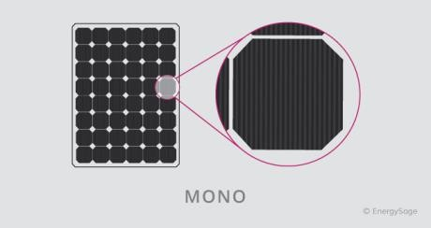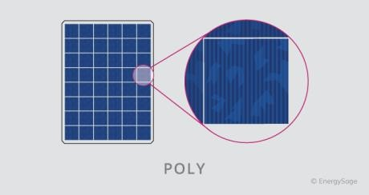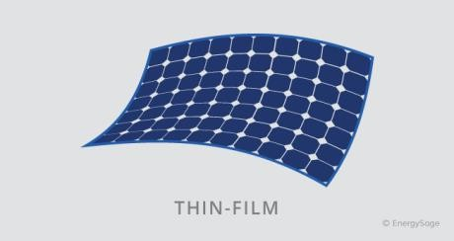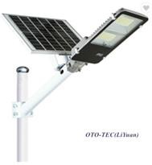
CUSTOMIZED MANUFACTURING

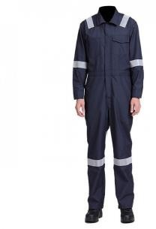
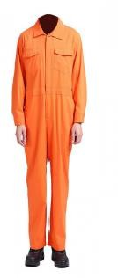

MATERIAL TRADING

Construction Safety Uniforms | Safety Coverall Welder Fire Retardant Coverall | Fire Retard Hoods
100% Cotton Fire Retardant Garment. GSM: 220 to 350 - Made in Pakistan

Rigger Safety Gloves Scaffolding Safety Gloves Safety Working Gloves Welders Safety Gloves Construction Safety Gloves Oil & Gas Safety Gloves Impact TRP Protection Gloves
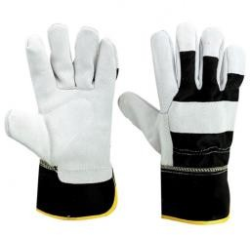
Tig Welding & Hi-Viz Safety Gloves General Handling Working Gloves

100% Pure Shoulder split cowhide leather 100 % Pure goat leather for reinforced palms Cotton lined palm extra comfort
Grade: A/AB SIZE: S to XXXL
Leather Made in Pakistan

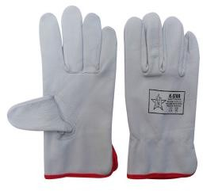
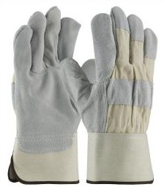
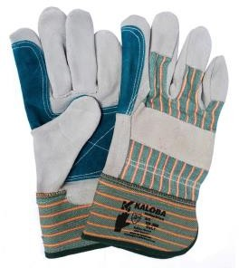
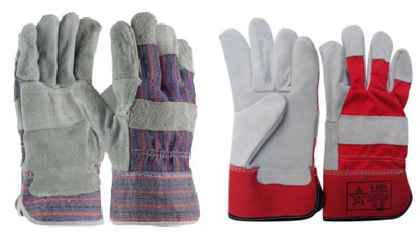
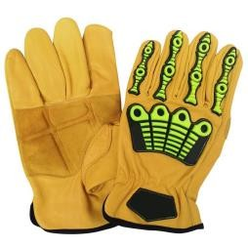
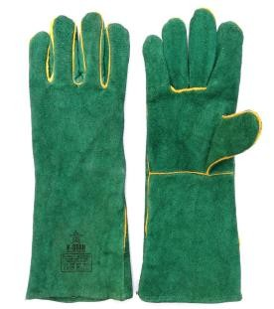
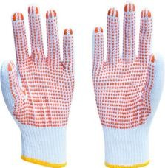
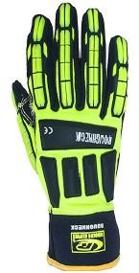

MANPOWER SOLUTIONS

We successfully supply manpower and labor services to various industries. Our manpower supply services always helps in recruiting the right candidates for the prescribed jobs in various companies. This helps in saving time, Cost & energy of our client’s. Before we provide the required manpower or labor to our clients.
We check the candidates on following basis:
- Behavioral Interviews
- Training Sessions
- Reference Checking
- Legal Status
- Exact Documentation
Our Manpower consists full of engineering discipline to provide solution to various industries according to its technical structure. The company is having a team comprising of different nationals across the world, well trained, dedicated in approach to provide services in different spheres.

  - Project Assistants
  - Administrative Assistant
  - Document Controllers
  - Material Controllers
  - Rigging Supervisors
  - Rigger Level I
  - Rigger Level II
  - Rigger Level III
  - Scaffolding Supervisors
  - Quantity Surveyors
  - Planning Engineers
  - Pipeline Engineers
  - Instrument Engineers
  - Electrical Engineers
  - SCADA/Telecom Engineers
  - Rotating Equipment Engineers
  - Static Equipment Engineers
  - Corrosion Engineers
  - Commissioning Engineers
  - Process Engineer
- Cost Control Engineers
- Estimation Engineers
- QA/QC Engineer
- QA/QC Inspectors
- PDMS Designers
- CAD Draughtsman
- Loss Prevention engineer
- Fire & Safety Engineers
- HSE Supervisor
- HSE Officer

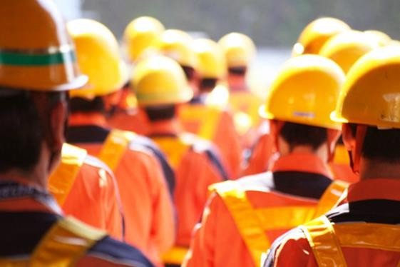
  - Technicians
  - Electricians
  - Mechanics
  - Permit Receivers
  - Fire Watch
  - Specialized Scaffolders
  - Asphalt workers
  - Shuttering
  - Pipe Fitters
  - Painters
  - Sand Blasters
  - Steel Fixers
  - Steel Fabricators
  - Masons
    - Iron Workers
    - Welders
    - Finishing Carpenters
    - Drivers
    - Office Boy
    - Skilled Helpers

